(Approx. 443 words)

Windows 8/8.1 Corner
Downloading, Purchasing and Installing Apps
By Rosita Herrick, Yahoo Forum Moderator, Sarasota Technology User Group, FL
http://thestug.org/
Rosita (at) thestug.org

In addition to being a computer operating system, Windows 8.1 is blurring the line between the old ways of working on a computer and the access to information used by tablets and smart phones. The distribution of apps that perform individual tasks is one of the ways.

In additions to apps that come with the operating system, Microsoft has created a store for apps distribution.

The Store APP
The Store app can be found either on the Start screen or on the Task bar.

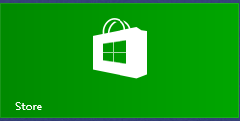

Access to the Internet is required for accessing the Store.

- You access the store app by clicking on the tile/icon.
- When the app opens you have quite a few options to search for items of interest.
- Once you find an app of interest, just click on it and on the page that opens you will find information about the app such as number of downloads, reviews with rating and a description of the app.
- The app might be free, might have a price or it can be downloaded for trial.
- Usually a Microsoft account is required.
- To install the app, just click on the Install button.

Maintaining Apps

Periodically, there are updates for apps to either enhance them or fix some problem.

To check for updates go to the Store app.
On the upper right side of the screen, if there are updates available for any of the apps, you will see a link in green



In this case there are updates available for 3 of my installed apps (not distributed with the system.
Clicking on this link displays the 3 apps that are scheduled for an update.

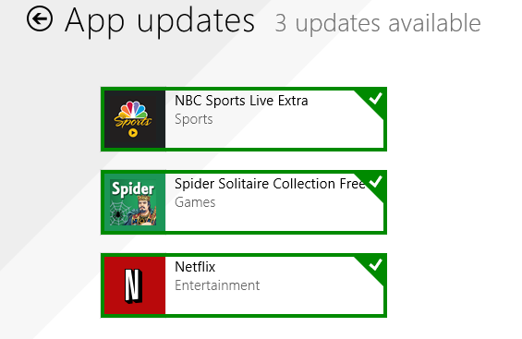

The check mark on the right corner shows that the update is selected to install. It can be unchecked with a right click

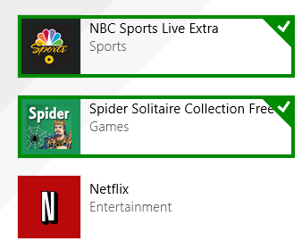

Now I can update the two remaining apps by clicking on the install icon at the bottom of the page.

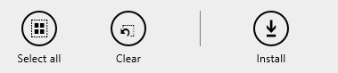

Once I click on install, the following page displays

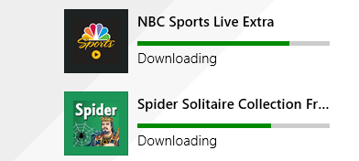

The amount of time and download and install takes, depends on the speed of your internet connection, the size of the update and the speed of your computer.

Once the download and install are completed the next message on the screen will be:

Your apps were installed

You can now close the Store app.

Uninstalling an app

This process is very simple.

- Find the app with the search charm.
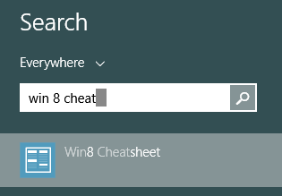

- Right click on the icon and this box will appear.

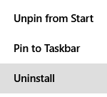
- Click on Uninstall and Windows will remove the app from your system.

